Weekly Schedule

Sunday:
Bible Study (all ages) 9:30 AM
Worship Service 10:30 AM
(includes Children’s Church)

Wednesday:
Loaves and Fishes Food Pantry 3:30-6:15 PM
(Brook Baptist is an equal opportunity provider.)

Tuesday:
Prayer Fellowship 6:30 PM

Directions to Brook Baptist:
Independence
Hospital

Wells Fargo

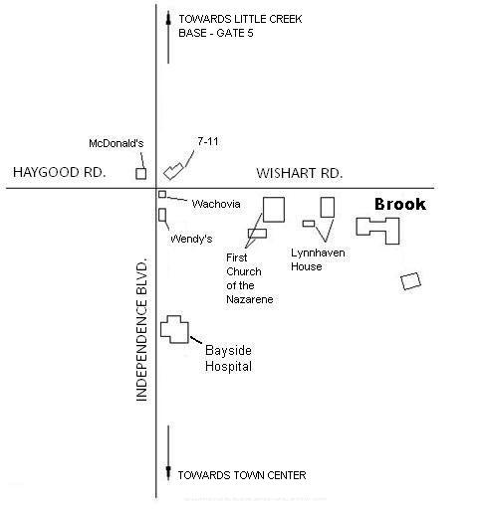

"For your progress
and joy
in the faith"
Philippians 1:25

Church Staff
Pastor – David Howard
Music Minister – Saul Fox

BROOK BAPTIST CHURCH
4397 WISHART ROAD
VIRGINIA BEACH, VA 23455
PHONE (757) 464-0371
FAX (757) 460-9809

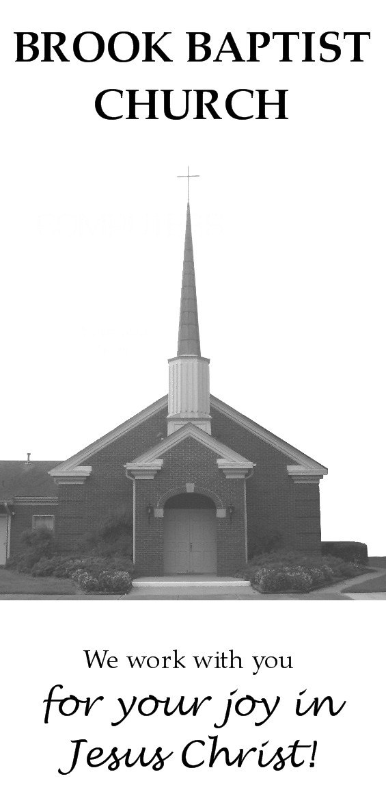

What Makes Us Different?

There are a lot of churches in the area. What makes us different? Why would you want to come to Brook?

We believe that God wants you to have joy. We don’t think that following Jesus is about duty and a lot of rules, because we don’t believe that God is boring. We believe He created you to find your true joy in Him—and you aren’t boring, are you? That’s because He created you “in His image,” or likeness. Following God is the most exciting and joyful thing you can ever do. And once you begin to do it, you find out that it’s not really about you at all; it’s about Him. Since He is so amazing, you will have joy in both the good and the difficult times. You will be in awe of Him and the things you realize He is doing. You will be amazed that God was willing to send Jesus to teach us about Him and to die in our place, so that we can have great joy forever.

We believe God’s Word is so important. This may not sound different, but many times all you will hear about God’s Word is one or two verses surrounded by illustrative stories and jokes. We think God’s Word is more fascinating than that, and it deserves more attention. God communicates to us through His Word; it is alive! We want to know what He is saying to us.

We believe children can learn more about God than most people think they can. They are capable of very deep thoughts, because they ask questions and make observations which demonstrate that. Why teach them only the same facts about Bible events over and over? They can also learn about who God is and what He is like through those events, in a way that is God-centered and on a level that they can understand which will be helpful to them in their day-to-day lives.

God has made us a multi-cultural family. The Bible says that there will people from every tribe and tongue and nation in heaven, and we don’t think they will be separated from each other into different corners! We love that He did this because we think it is what our future together will be like, and we get a little taste of it now!

We believe God wants us to actively show His love, but not just to those who are currently a part of our church family.
He has blessed us with our Loaves and Fishes food pantry ministry to help those in need of food. Each month, we are able to assist over 150 families and 600 individuals in this way. We do this because we want people to know that God cares about them.

God cares about you. What are you doing to find out about Him?

Our Vision

Our vision at Brook Baptist is to bring honor and praise to Jesus Christ in everything we do. Therefore, we desire to:

- Help all people realize that God is most honored when we find our happiness in Him through Jesus Christ.
- Lead our congregation to be united together in a special way in the love of Jesus Christ.

With this vision, we put a high priority on:

1) Worship: our public expression of praise and thanksgiving;

2) Preaching and Teaching: by which we learn together from God’s Word how to find our happiness in God, how to serve God and others, and how to experience unity together;

3) Committed Christian Living: the active demonstration of our faith through a lifestyle that honors God in all things;

4) Service: by which we help each other in the church in our relationship with God through instruction, encouragement, prayer, and acts of kindness;

5) Deeds of Mercy and Evangelism: by which the love of Jesus flows through us toward the needy and those who don’t know Jesus.

These priorities are reflected in all of our areas of ministry.

